# Working Title

Plant View

# Project Description

I will be developing an Android application intended to be used on a tablet. The application will make use of the tablets camera, GPS and Wi-Fi capabilities. It is intended to be used on an industrial site to provide the user with information on the equipment and vessels within their immediate area. The camera would be used to show the user what the tablet can see and also provide a user interface for selecting information. Once an item has been selected the application will be able to show the user relevant information about that item that they would want to know. This could include things such as current temperature and the temperature history over time. With this information the user could then decide if any immediate action needed to be taken. The camera can also be used to scan QR codes to make it easier to select an item if there are a lot in a small area.

In order to be able to mark the locations that the Android application will pick up a separate web application will be developed to put each point on a map. It will use google maps to allow the user to see exactly where they are placing the point. Once a point has been placed it can be named and it will be stored in a database along with the latitude and longitude. The web application will also work on the tablet, allowing the user to walk around and plot new points as they see fit.

# Rationale for Choice

The project idea was provided to me by a local company called Sabisu who employed me during my year in industry. Towards the end of my placement I was given a project specification of what they wanted. Since then I have been it to speak with my manager to further flesh out the specification and talk about technical details and challenges I would face. I have also been having bi-weekly meetings with my project supervisor from Sabisu to discuss progress and next steps in the project.

Android has been chosen as Sabisu use Getac tablets that Android has also been a passion of mine for a couple of years so I am looking forward to be able create a fully-fledged professional Android application, that will be used by people and be able to help make their jobs easier. Developing the app will build on my knowledge from personal projects as well as the work done during the Enterprise Project in second year. It will also allow me to explore new aspects of Android that I haven’t tried before such as reading data from a web service and using the devices compass to find the users orientation. Furthermore, it is the only suitable choice as there are only two main competitor operating systems in mobile devices, iOS and Android. iOS is not suitable as it normally requires a machine running Apple’s OSX and the devices to run the application on aren’t as common as Android devices, especially in the chemical industry where the devices on plant need to be intrinsically safe.

Finally, as the server side code will be written in Node JS this will give me the opportunity to learn a framework that I have been wanting to try for a while. Also as Node JS is a very up and coming technology I feel that it would help with my job prospects if I can prove that I can use it effectively.

# Areas for Investigation

Libraries etc – research needed to be done

# Background Research

## Web application

When deciding what language to use for the server side code of the web application was a large number of languages I could have chosen to investigate, for example Python, PHP, Java or Ruby. However, I chose to look into .NET and Node.JS, I chose .NET as it is a framework that I am familiar with and I knew could get the job done. The reason for choosing Node.JS is that I’m familiar with using JavaScript in a client side setting and thought it would be interesting to see how it works server side.

If I chose to use .NET there would be a number of advantages. Since it’s a language that I’ve learnt both at university and on placement it would be relatively simple and quick to develop. This would be further increased by the templating that Visual Studio could provide, meaning that there wouldn’t be that much code to write. Also the majority of Sabisu’s applications use .NET for their server side code so if the application was to be adopted by them it would be easy to maintain.

However, if I chose to use Node.JS it would be a good learning experience for me and would also build on my knowledge of JavaScript. Furthermore, I think it would be a more suitable language for this task. As the web app is only a small application for adding points to a database a large .NET app with all its dependencies on Entity Framework etc. it could be a bit too cumbersome. Also if for some reason the application did need to be scaled up or down it could be easily done so if it was deployed to something like Docker [10].

## Android Application

Again for the Android application there are a number of methods I could use for development. Most Android applications are written in Java and then run on the Java Virtual Machine (JVM) within Android, apps can also be written in C or C++ using the Android Native Development Kit (NDK). Apps written with the NDK tend to perform better as they are run directly by the OS instead of using the JVM. However, I don’t think that my application would benefit from using the NDK and the unfamiliarity with C/C++ would hinder rather than help me.

Even excluding the NDK there are still multiple choices that I could use. Soon after I was given the brief for the project the head of Sabisu suggested that I looked into using the Unity engine [12] and the augmented reality libraries available for it. After some research I found the Vuforia [11] library which uses image recognition display items on the devices screen. However, after developing a test application I found that it wasn’t good for recognising simple shapes and requires knowledge of the image needs to recognise which would not be feasible in an industrial setting. So for this reason, I ruled out using Unity and Vuforia.

After ruling out the previous technologies this left using Java and the Android Software Development Kit (SDK). Java is a language that I am very familiar with having used it on both the desktop and for creating Android applications. Also it is the main language of choice used within the Android development community so there will be plenty of support online and libraries to use.

However even after deciding to use Java and the Android SDK there was one more language I found to use, Kotlin. Kotlin is a language that will run on the JVM so has complete interoperability with normal Java. The advantages of Kotlin is that it removes some of the nuances of Java such as Null pointer exceptions, the large amount of boilerplate code. Due to the strong interoperability with Java it means that I will still have access to existing Android libraries and can write sections of code in Java if needed.

## Integrated Development Environments (IDE)

To develop the Android application, I will be using Android Studio as it is the official IDE provided and supported by Google. It includes features such as being able to create an Android emulator, pushing builds to a device and instant code run.

For everything else I will be using Visual Studio as it allows compilation of web projects and the bundling of scripts using Microsoft’s Razor engine. It can also act as a text editor for Node.JS and still provide features such as intellisense.

# Literature Review

## Books

*Professional Android 4 application development (Meier, Retro, 2012) [3]*

Although this is a slightly older book, it is one I have used it before and it provides the fundamentals for Android development.

*Android for programmers: an App-driven approach (Deitel, Paul J et al., 2015) [4]*

This being a more modern book should provide some new features that could build on the basic fundamentals. It is based on Android 6.0 which currently has the largest market share for Android devices [5]

## Articles

Kotlin for Android Developers (Antonio Leiva, 2015) [6]

An article highlighting some of the key features of Kotlin, it includes code samples to easily get the point across and see the implementation. This will be useful as I am new to using Kotlin.

Android Data Binding Library: A Blitzkrieg (Aditya Ladwa, 2017) [7]

Data binding in Android is a library that I have used previously and has proved to be very powerful and useful. This article shows how to set it up and integrate it with my Java classes.

## Websites

Android Compass Example (Viacheslav Iutin, July 2015) [8]

A GitHub repository containing an example of how to use the compass on Android. This is useful as it is not something I’ve used before. Getting the location of a device is easy but getting the direction being faced is a bit more complex

Kotlin (Jetbrains, 2017) [9]

The website for the Kotlin programming language, it has the official Kotlin reference guide as well as tutorials and getting started guides.

# Methodology

When planning a project there are a range of methods and techniques that can be used to most effectively plan out what needs to be done and when it should be done by. Project management methodologies can be split up into a number of groups, these include sequential, agile and change management [1].

An example of a sequential methodology is waterfall. Waterfall means that each section is fully completed before moving onto the next step and stops backwards steps. This means that ideally each step will be perfect in order to move onto the next one. However, as I am working with a real client this is not always the case as requirements often change. So as the waterfall methodology doesn’t fit around revisiting previous stages I don’t think it would be a suitable strategy.

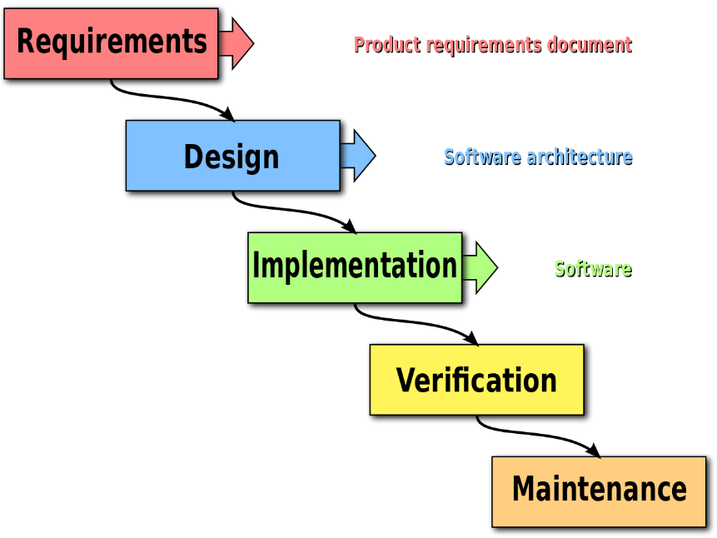

*Waterfall methodology*

An example of an agile methodology is Scrum. Scrum involves splitting up the project into small tasks sometimes known as story points, this helps the members of the project easily see what has been done and what is left to do. Scrum can also be combined with another methodology called Kanban [2], which utilises story points and puts them into groups such as “to do”, “development”, “testing” and “done”. Another key feature of Scrum is the use of sprints; sprints are a short period of time normally one or two weeks where a chunk of development work is done. After a sprint the current stage of the project is shown to the customer and reviewed, this keeps engagement with the customer and allows for any changes to be made in a future sprint. By keeping in contact with the customer this makes sure that they end up with exactly what they want and they can see how much progress is being made.

As I have a live customer I think that Scrum is the best methodology to use, sprints will be one week long as this fits in with my weekly meeting with my project supervisor at Sabisu. Since I am the only developer working on the project there will not be a potentially shippable product at the end of each sprint, but a reasonable segment or feature should have been implemented after each sprint.

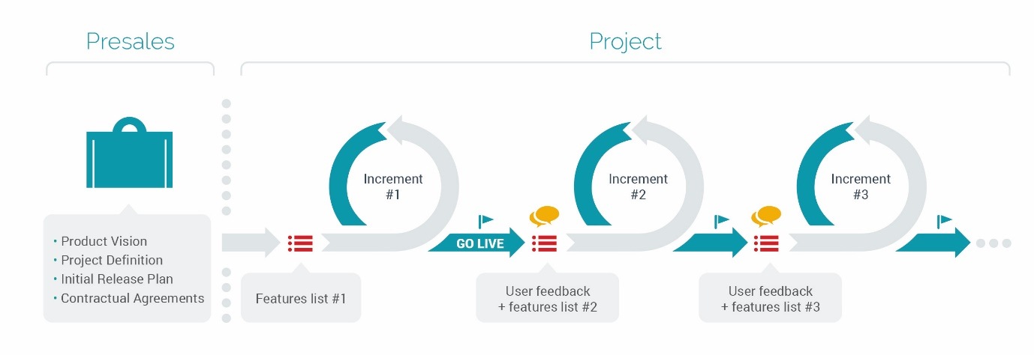

*Scrum sprint cycle*

# Research Ethics

British computer society ethics, professional issues – real client

Note that I only read the information

Since I am working with a real client I feel that it is important that I adhere to the British Computer Society code of conduct [13]. The section that would apply specifically would be “professional competence and integrity” meaning that I should only undertake work that I think I am competent of and I should be willing to accept criticisms and alternative viewpoints.

As my application is intended to be used within the chemical industry it could be reporting some critical information to the user. However, as the application is only reading the information from a data source that has been inputted by another system I don’t think that my application has any ethical issues in this regard.

# Project Plan

|  |  |  |  |
| --- | --- | --- | --- |
| Week Number | Week Commencing | Task | Deadlines |
| 1 | 30/01/2017 | Finish work on web application | - |
| 2 | 06/02/2017 | Testing of web app and start on C# web service | - |
| 3 | 13/02/2017 | Completion of C# web service and testing | - |
| 4 | 20/02/2017 | Start of Android Application – basic camera and location functionality. Start of review poster | - |
| 5 | 27/02/2017 | App development – compass working. Finish poster, start report | Poster review |
| 6 | 06/03/2017 | App development – connecting with Node JS web service & C#.  Report on going | - |
| 7 | 13/03/2017 | App development – UI implementation.  Report on going | - |
| 8 | 20/03/2017 | App development – showing data on UI.  Report on going | - |
| 9 | 27/03/2017 | App development – adding graphs.  Report on going | - |
| Easter Week 1 | 03/04/2017 | App development – QR scanning.  Report on going | - |
| Easter Week 2 | 10/04/2017 | App testing, rework from testing. Report on going | - |
| Easter Week 3 | 17/04/2017 | Rework from testing | - |
| 10 | 24/04/2017 | Report | - |
| 11 | 01/05/2017 | Report and final checks on all aspects of project | - |
| 12 | 08/05/2017 | Review of report | Report and item submission |
| 13 | 15/05/2017 | Project Viva 1 | - |
| 14 | 22/05/2017 | Project Viva 2 | - |

# Deliverables

Web app, web service, android application and report

# References

1. <https://www.wrike.com/project-management-guide/methodologies/> (accessed 30/01/2017)
2. <http://www.agileweboperations.com/scrum-vs-kanban> (accessed 31/01/2017)
3. Professional Android 4
4. Android for programmers
5. <https://developer.android.com/about/dashboards/index.html> (accessed 31/01/2017)
6. Kotlin for Android Developers, available at: <http://www.javaadvent.com/2015/12/kotlin-android.html> Antonio Leiva, December 2015 (accessed 31/01/2017)
7. Android Data Binding Library: A Blitzkrieg, available at: <https://medium.com/@ladwa.aditya/android-data-binding-library-a-blitzkrieg-504fc4462352#.6cqrwdpqx> Aditya Ladwa, January 2017 (accessed 31/01/2017)
8. Android Compass Example, available at: <https://github.com/iutinvg/compass> Viacheslav Iutin, July 2015 (accessed 31/01/2017)
9. Kotlin, available at: <https://kotlinlang.org/> JetBrains, 2017 (accessed 31/01/2017)
10. Docker, available at: <https://www.docker.com/> Docker, 2016 (accessed 01/02/2017)
11. Vuforia, available at: <https://www.vuforia.com/> PTC inc, 2017 (accessed 01/02/2017)
12. Unity, available at: <https://unity3d.com/> Unity Technologies, 2017 (accessed 01/02/2017)
13. BCS Code of Conduct, available at: <http://www.bcs.org/category/6030> BCS, 2017 (accessed 01/02/2017)